Science and Forest School
What materials were castles and items from castles made of?
Investigate which material will make the best castle door, flag etc.
Forest school activities with Mrs Morgan
Collecting materials and making flags, crowns.

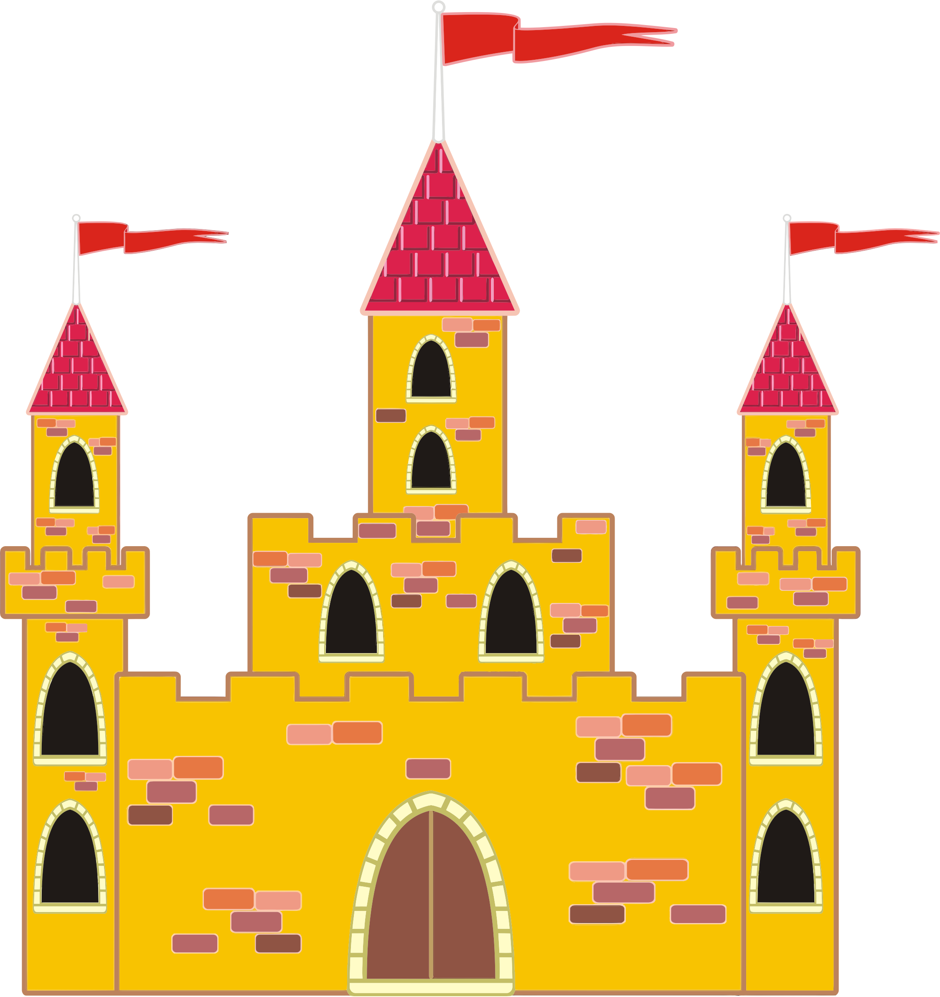
Art/DT
Portraits of Kings, Queens
Paintings of Dragons and castles
Design and make a family flag
Castles and Sun – Paul Klee – Artist study

Geography/History
Continents and oceans of the World
Invent castle maps using symbols and keys
Read a map to find clues for a treasure hunt around school
Ways of life of people in the past. What did it mean to be a King, Queen, Maid, Jester, Cook? What was life like for a Knight?
Famous Kings, Queens, Dragon stories.

RE
Stories from different religions

PE
Amaven planning and assessment.
Music
Medieval songs and rhymes
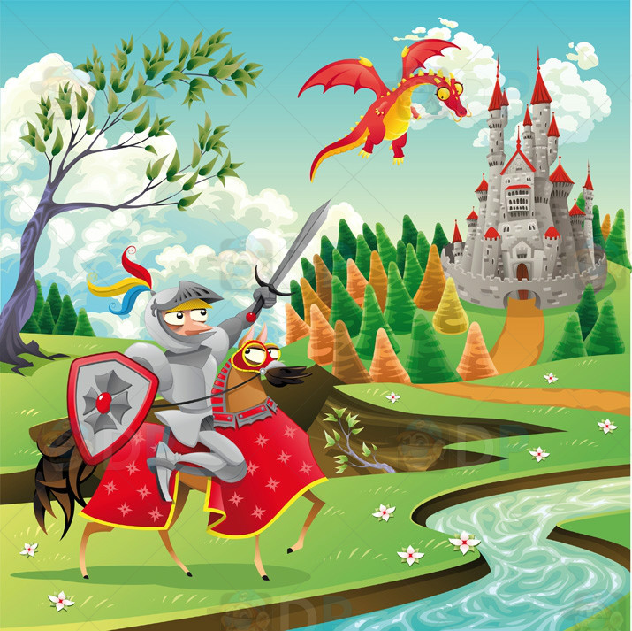
Medieval Magic
Year 1 - Autumn – 2017
Literacy - Rapunzel, Castles, Princess and The Pea etc
Exploring castle settings
Write about life in a Castle
Dragon poems.
Writing letters and postcards
Year 1 Phonics
Letters and sounds
Using adjectives to describe Rapunzel.
Maths
Numbers up to 10
Addition and subtraction within 10
Recognising 2D and 3D shapes
Turns – half, quarter and full turn.
Numbers up to 20 Addition and subtraction within 20
ICT
Making King, Queen posters using Word.
Using Paint programme to turn photos of ourselves into Queens, Kings
Phonics and maths games
iPads – photo, piccollage

PSHE
Getting to know you activities.
Discuss castle rules and punishments
Feeling proud – of themselves and of friends
How to deal with feelings of worry or anxiety

