 | WEAVER PRIMARY SCHOOL  WESTERN AVENUE  NANTWICH  CHESHIRE  CW5 7AJ |  | 
Headteacher  Mrs Gill Price |  | Tel: 01270 626335  e-mail: head@weaver.cheshire.sch.uk
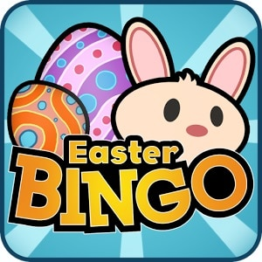
‘EYES DOWN’ FOR EASTER BINGO NIGHT!!
Friday 19th April
6.00pm-8.00pm

Well it may not feel like it but spring is on its way, so it must be time for a bingo night! A family friendly evening of great fun, food and prizes. Tickets are limited to 100 and will sell out fast, so make sure you get yours early!

To create Easter themed hampers for the prizes we are having a non-uniform day on Thursday 28th March, please bring in an Easter Egg or Easter themed gift to go in the hampers, in return for dressing in your own clothes.

The licenced bar will open at 6.00pm, and nachos will be available to buy. There will also be a tuck shop for the children. The first bingo game will start at 6.15pm, with a short interval for refuelling half way through! The ticket price for Easter bingo is £1.00 per person (including children), which includes 1 bingo card (6 games). Additional bingo game cards can be purchased on the night for £1.00 each and £2 each for the ‘BIG’ game.

If you would like to come to this event, please fill in the reply slip below and return it with your ticket money. If you are able to help during the evening with selling bingo cards, or serving refreshments, please indicate on the slip below.

We look forward to seeing you there!
Weaver School Association
.......................................................................................................................................................
I/We would like to purchase ........tickets for Easter bingo
(Cheques payable to Weaver School Association)
I enclose £...................
Childs name..............................................................Class............................
Please tick here if you can help on the night............................ and put your email address below

……………………………………………………………………………………………………………………………………………………………………………

